

**UNIVERSIDAD TECNOLÓGICA DE**

**SAN LUIS RIO COLORADO**

**PRACTICA 3**

**MTRO. RICADO ALEJANDRO SOTO MORALES**

**AUTOR: VICTOR MANUEL GALVAN COVARRUBIAS**

San Luis Rio Colorado, Sonora Junio, 2020

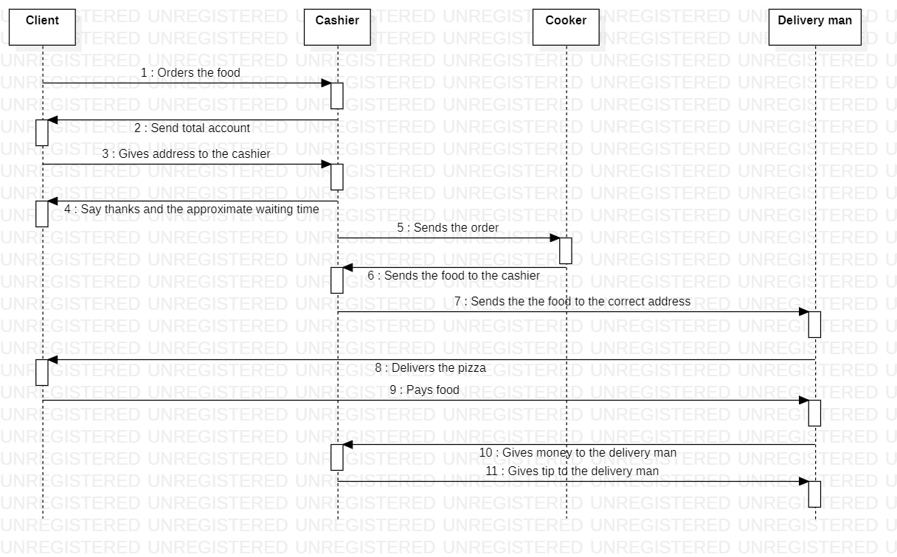

Illustration 1: Sequence diagram corresponding to the Pizza delivery process

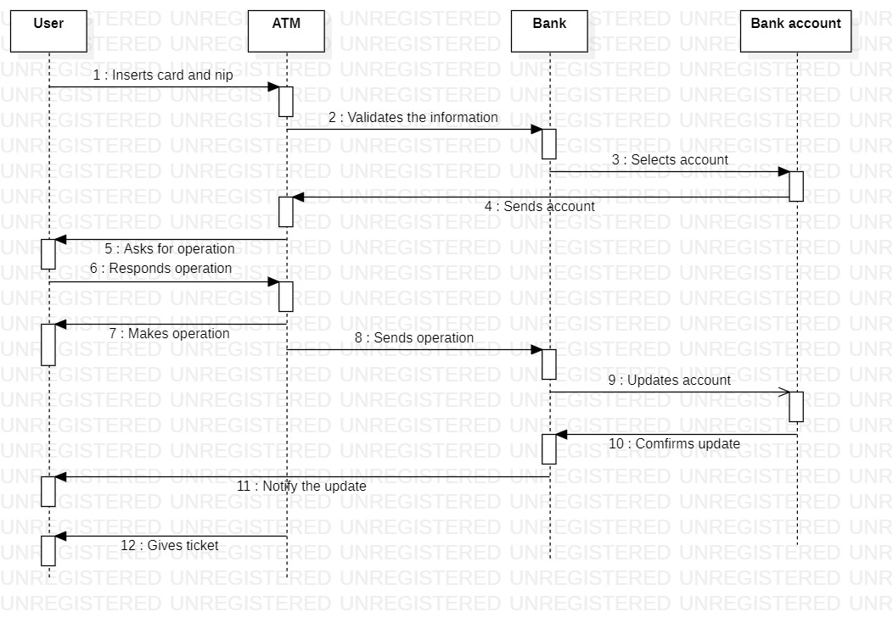

Illustration 2: Sequence diagram corresponding to a Client using an ATM

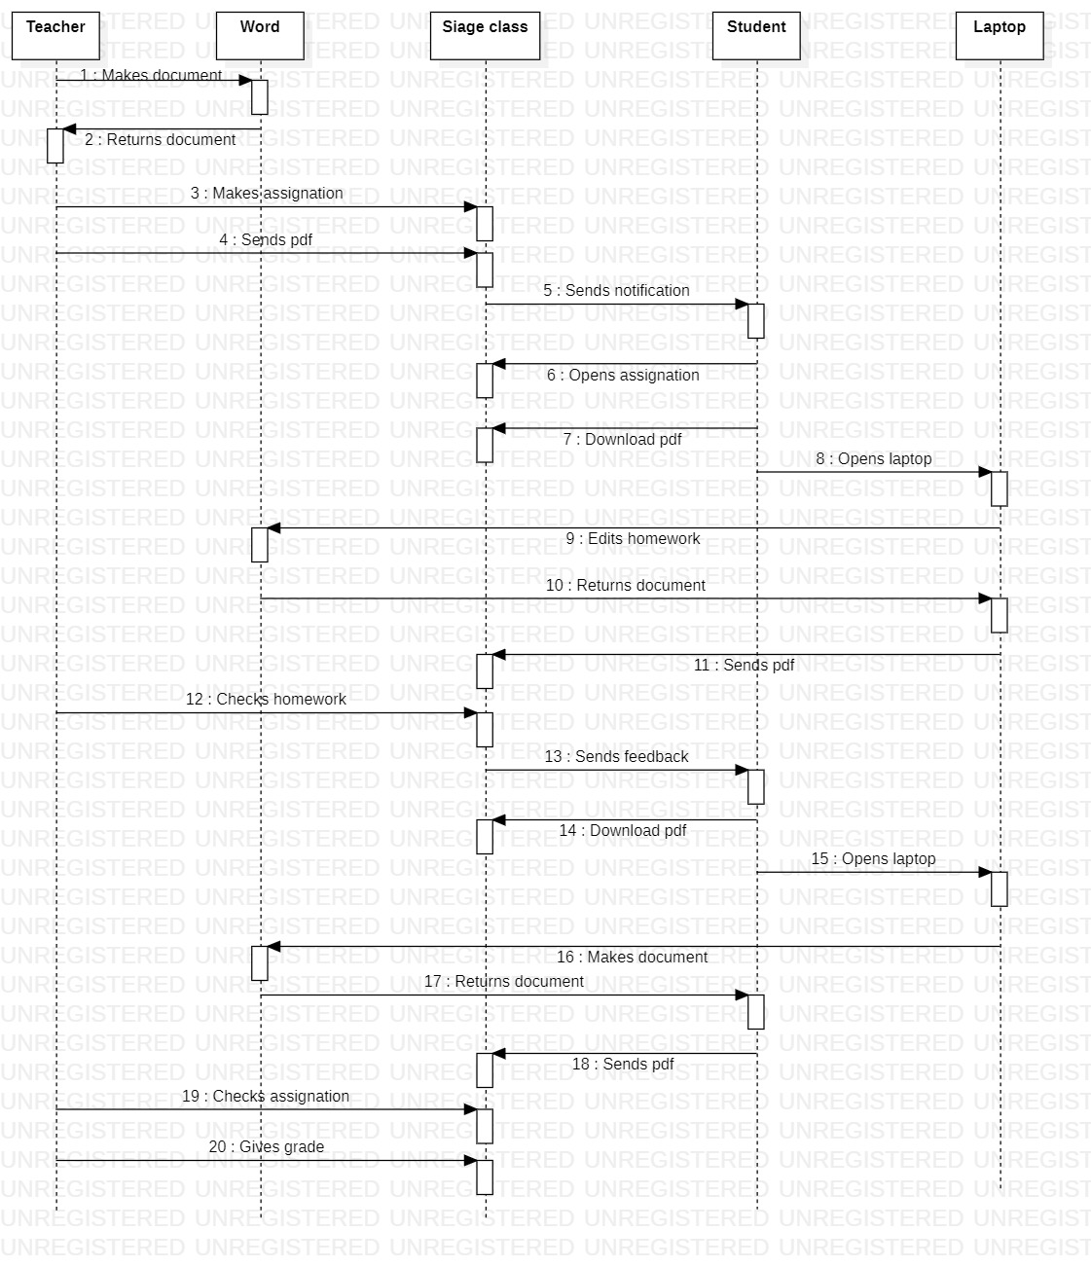

Illustration 3: Sequence diagram corresponding to an assignation in SIAGE class

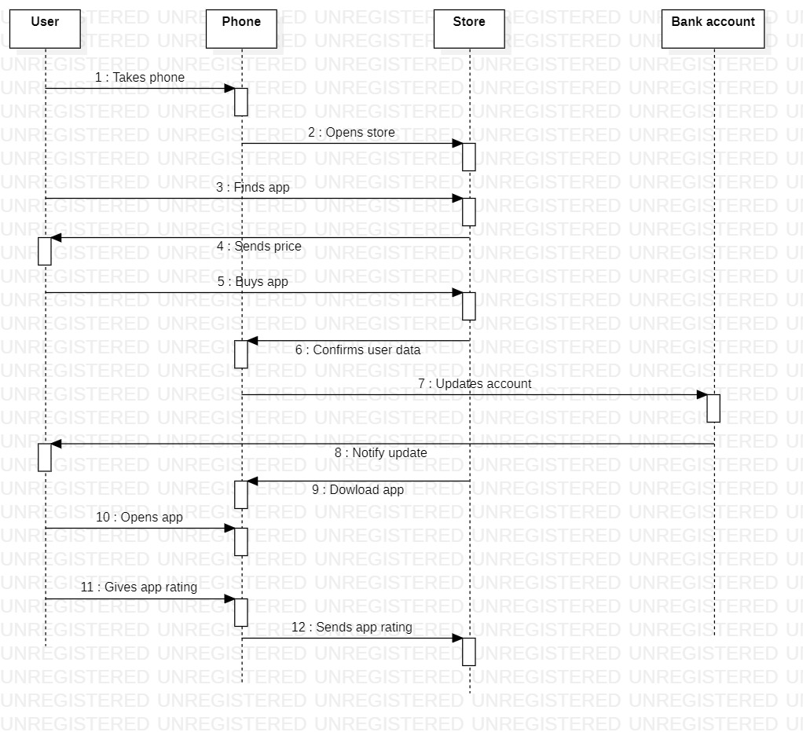

Illustration 4: Sequence diagram corresponding to the purchase of a mobile application in Android

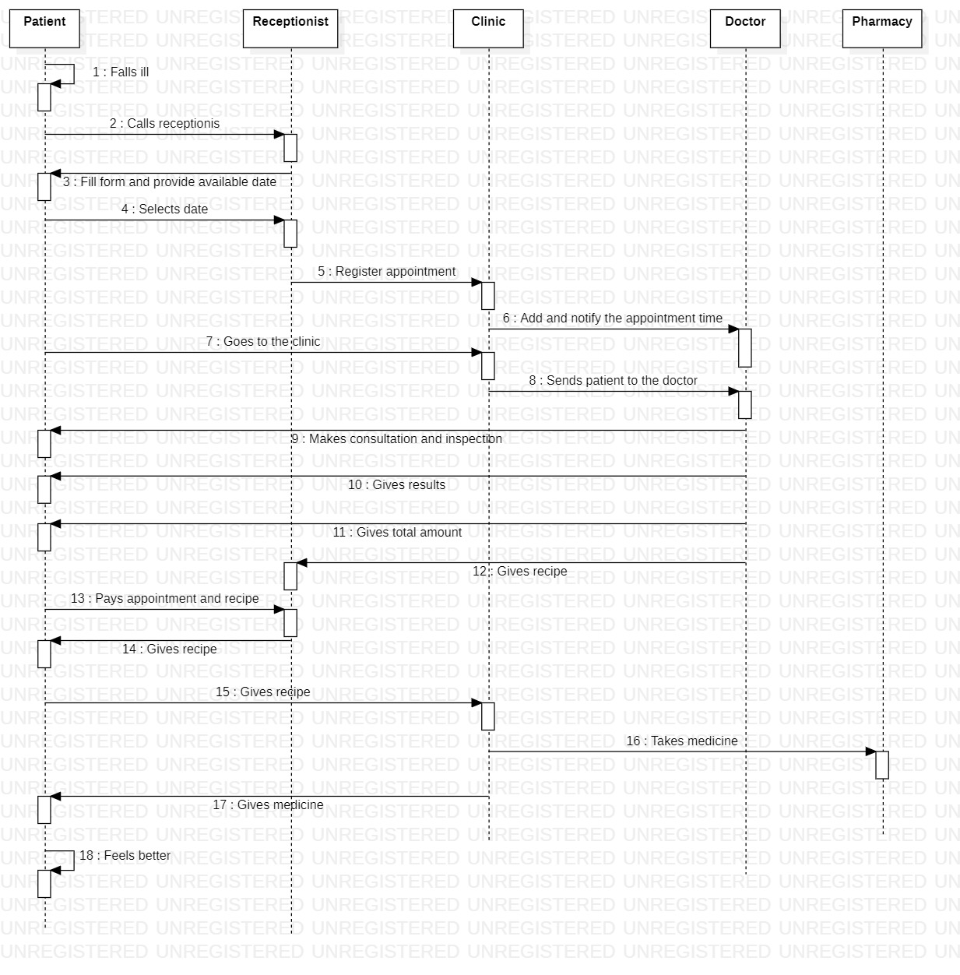

Illustration 5: Sequence diagram corresponding to the steps performed for a person to attend the doctor